Introduction for Consumers of Cognos Reports

- How to access Cognos
  - To access Cognos to run your reports, you will use the RESOURCES tab on Pirate Net. If you are a Graduate Assistant, you will use the Technology tab. On the tab, you will see a box titled “Reports”. This box contains four items:
    - Cognos link – this will take you to the Cognos home page where you will use your Pirate Net authentication credentials to log into Cognos.
    - Data Cookbook – this will take you to the Data Cookbook where you will use your PirateNet authentication credentials to log into Cookbook. You can find information about the Cognos reports (Inventory of Reports; Functional and Technical definitions of Terminology used within Reports).
    - E-Print link – this will allow you to access your e-Print reports
    - Introduction for Consumers of Cognos Reports – training documentation and FAQ’s

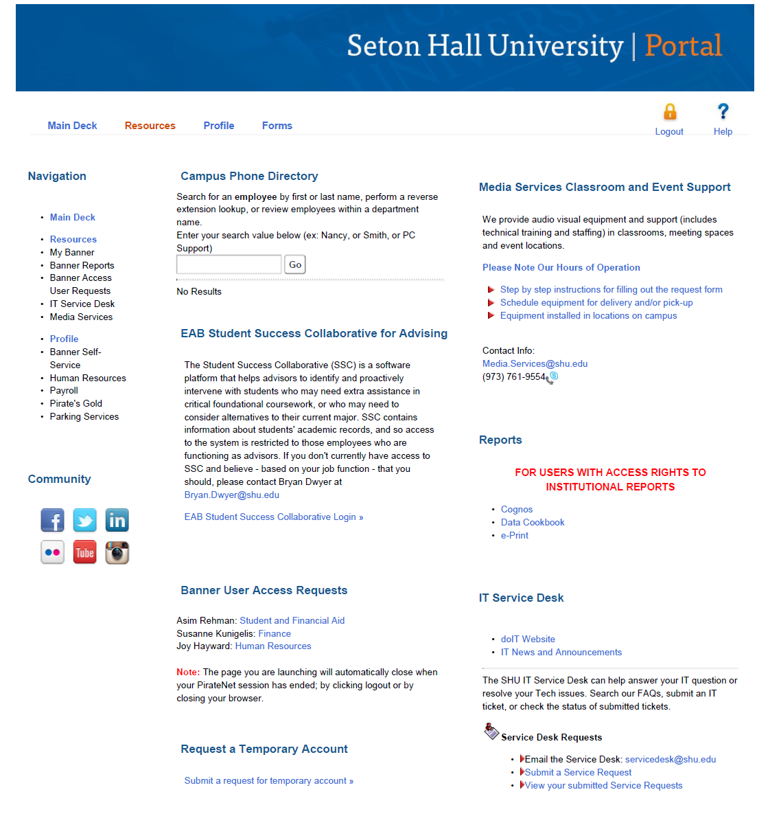

- NOTE: Your Cognos reports are run against the ODS. This means that all your reports will be running against yesterday’s data (copied from Banner at around 6 am each day), not live data from Banner.

- When you log into Cognos for the first time you will see the following screen:

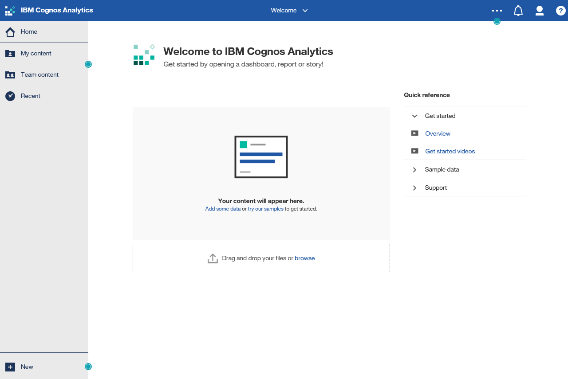

  - ‘Team Content’ is where you have access to all the folders that you have permission to view, as well as the Cognos Class Examples folder.
  - ‘My Content’ is where reports you have copied will reside.
  - ‘Recent’ will provide you with direct links to the last several reports you accessed.

  - NEW FEATURE NOTE: The space in the middle of screen will be used to save your recently run reports as Tiles. Next time you want to run the report, you can click on the Tile instead of following the traditional path.
- Click on ‘Team Content’ to get an expanded view.
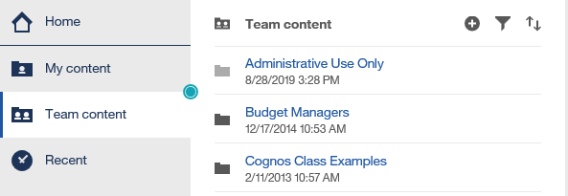

- Click on the folder for the reports you wish to view (example: Cognos Class Examples)
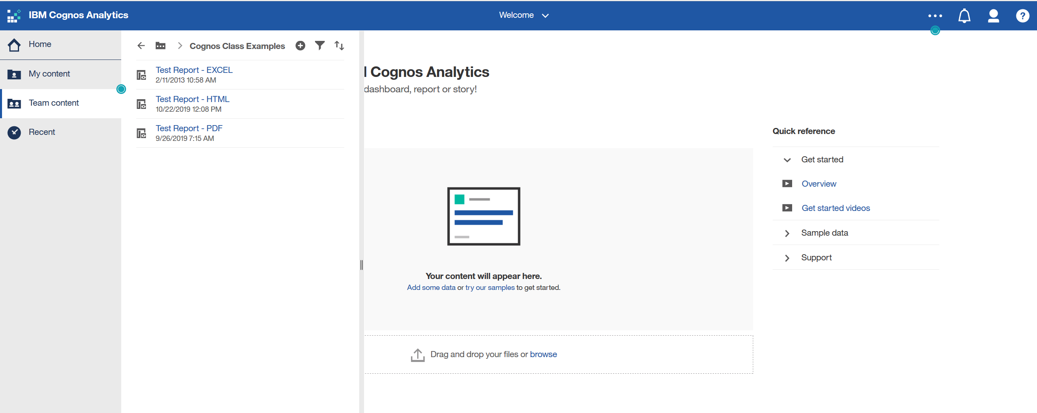

- You are ready to run your reports
  - You can run by just clicking on the report name. If you click on the report name, the prompt page for the report will be displayed (if the report requires prompts). Enter the prompts and hit the Finish button. The report will then run and be formatted in HTML output, or the output format saved for that report, to the screen.
  - You can also run the report by clicking the three blue dots that appear when you hover over the report. This will allow you to pick the output format of the report (HTML, PDF, versions of EXCEL, CSV, or XML).
  - Hit RUN, the prompt page will appear (if there is one), after entering the required prompts, hit Finish, and your report will run to the format you selected. The icons to the left of the report name show the default format for the report.

Report View Icon Dashboard Icon Report Icon

  - Note: Some report formats have been predefined. Please contact the Data Steward if you need your output in a format other that what has been set.
  - If you run your report to HTML, you will see a link for the Data Cook Book in the footer of your report. If you click on the Data Cook Book hyperlink, the Data Cook Book will open in a new window.
  - To be able to save the output to the Cognos portal, copy your report to My Content.
    - Hover over the triple dots on the report and select Copy or Move
    - Select the My Content Folder and press Copy

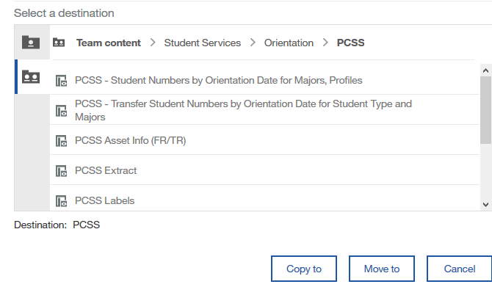

  - Notice the “breadcrumbs” at the top of the screenshot.

  - Once your report is in My Content, you will be able to save the output, as well as setting the parameters for future runs.
  - If a report is changed once you have saved it in ‘My Content’ you will still get all the updates that are made by the Data Stewards to the reports
  - You can change your “Home” view by using the triple dots on the Cognos blue menu bar. This will allow you to set a report or dashboard as your home.

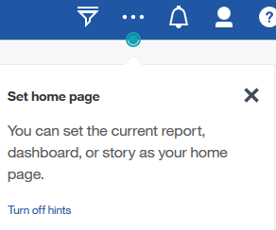
  - NEW FEATURE NOTE: You can also now use the Tiles on your Home page to access reports that you have recently run. Simply click on the Tile:

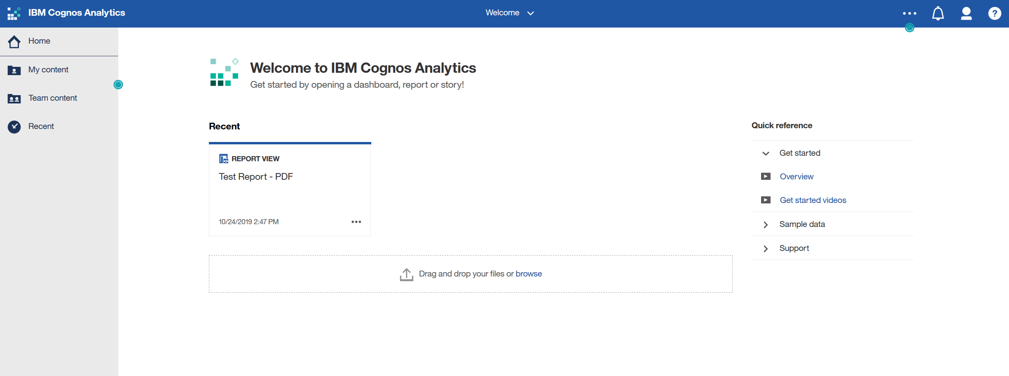

  - After you are finished running your reports, you should logoff Cognos using the drop down on the Person icon on the Cognos Menu Bar, and then signout. If you don’t logoff, Cognos has a timeout feature and will automatically log you off.

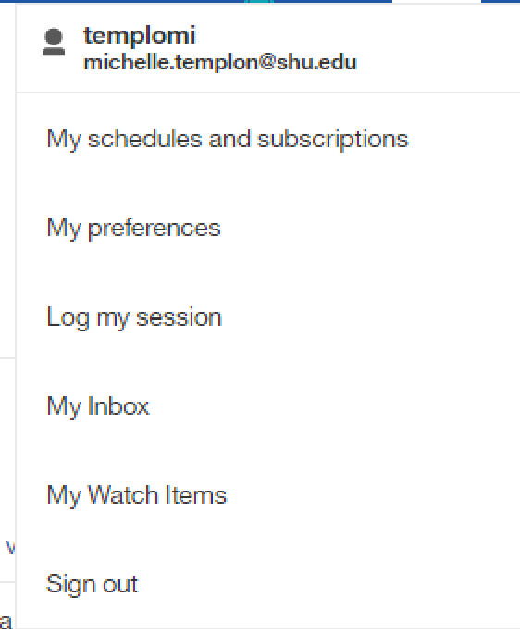
FAQ’s
- Who to call for questions or problems with Cognos
  - For problems with logging into Cognos, or the Cognos site is not available, please call the Service Desk at extension 2222 (973-275-2222).

  - If the data on your report does not look correct or you have other issues with the formatting of your reports, prompts etc., please call or send email to the Data Steward.

  - To request changes to a report, or for a new report to be developed, please contact the Data Steward.

  - Our current Data Stewards are as follows:

    - Banner Student and Financial Aid – Asim Rehman
    - Banner Finance – Susanne Kunigelis
    - Banner Human Resources – Joy Hayward

